Vibration module

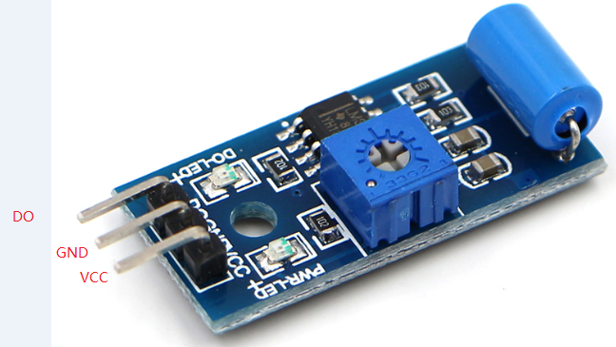

Vibration module arduinocontroller

DO 3

GND GND

VCC 5V